**Assignment 6**

**R-4.14**

Bubble sort is stable.

Heap sort is not a stable sort because of upHeaping.

Insertion sort is stable because the value swaps one by one and it doesn’t cross once it finds the equal value

Merge sort is not always stable but it can be stable if the first part of the values are always merged to left part and remaining to right part and if it continues the process.

Quicksort is not stable at all because the pivot is chosen randomly and value swaps from both sides.

**R-4.16**

The bucket sort uses O(n+N) space. Bucket sort moves items to different buckets to get them sorted. As a result, it’s not in-place.

**C-4.13**

**Algorithm** IsIdentical(A, B, x)

Input: A and B are sequences of n integers

Output: true if A and B have same elements, false otherwise

HeapSort(A) O(n log n)

HeapSort(B) O(n log n)

For i🡨0 to i = A.size()-1 do O(n)

If A.elemAtRank(i) ➢ B.elemAtRank(i) then O(n)

Return false O(1)

Return true O(1)

Total running time is O(n log n)

**R-5.4**

a) a=2, b=2, f(n) = log n

logb a = 1

case 1: log n ≤ n 1 - ᵋ

True for Ԑ = 0.5

T(n) is Ө(n)

b) a=8, b=2, f(n) = n2

logb a = 3

case 1: n2 ≤ n 3 - Ԑ

True for Ԑ = 1

T(n) is Ө(n3)

c) a=16, b=2, f(n)= (n log n)4

logb a = 4

Case 1: (n log n)4 ≤ n 4 - Ԑ

Not true for Ԑ > 0

Case 2: (n log n)4 = n4 logk n

True for k = 4

T(n) is Ө(n4 log5 n)

d) a=7, b=3, f(n) = n

logb a = 1.7712

Case 1: n ≤ n 1.7712 - Ԑ

True for Ԑ = 0.7712

T(n) is Ө(n1.7712)

e) a=9, b=3, f(n)= n3 log n

logb a = 2

Case 1: n3 log n≤ n2 - Ԑ

Not true for Ԑ > 0

Case 2: n3 log n = n2 logk n

Not true

Case 3: n3 log n ≥ n2 + Ԑ

True for Ԑ = 1

9 (n/3)3 log (n/3) ≤ δ n3 log n

1/3 n3 (log n – log 3) ≤ δ n3 log n

δ = 1/3, T(n) is Ө(n3 log n)

**Assignment 7**

**R-2.19**

h(12)= 7 h(44)= 5 h(13)=9 h(88)= 5 h(23)= 7 h(94)= 6 h(11)=6

h(39)= 6 h(20)=1 h(16)= 4 h(5)=4

0 1 2 3 4 5 6 7 8 9 10

|  |  |  |  |  |  |  |  |  |  |  |
| --- | --- | --- | --- | --- | --- | --- | --- | --- | --- | --- |
| Ø |  | Ø | Ø |  |  |  |  | Ø |  | Ø |

20 16 44 49 12 13

5 88 39 23 11

**R-2.20**

0 1 2 3 4 5 6 7 8 9 10

|  |  |  |  |  |  |  |  |  |  |  |
| --- | --- | --- | --- | --- | --- | --- | --- | --- | --- | --- |
| 11 | 39 | 20 | 5 | 16 | 44 | 88 | 12 | 23 | 13 | 94 |

**R-2.21**

0 1 2 3 4 5 6 7 8 9 10

|  |  |  |  |  |  |  |  |  |  |  |
| --- | --- | --- | --- | --- | --- | --- | --- | --- | --- | --- |
|  | 20 | 16 | 11 | 39 | 44 | 88 | 12 | 23 | 13 | 94 |

**R-2.22**

h’(12)= 2 h’(44)= 2 h’(13)= 2 h’(88)= 2 h’(23)= 2 h’(94)= 2

h’(11)= 3 h’(39)= 3 h’(20)=1 h’(16)=5 h’(5)= 2

0 1 2 3 4 5 6 7 8 9 10

|  |  |  |  |  |  |  |  |  |  |  |
| --- | --- | --- | --- | --- | --- | --- | --- | --- | --- | --- |
| 11 | 23 | 20 | 16 | 39 | 44 | 94 | 12 | 88 | 13 | 5 |

**Assignment 8**

**R-3.8**

No, the tree in the figure is not a (2,4) tree, because all external nodes don’t have the same depth

**R-3.10**

1. 5, 8 , 13, 17, 4, 6

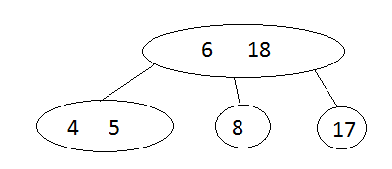

1. 13, 4, 8, 5, 6, 17

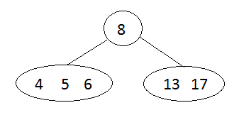

In conclusion, the (2,4) tree structure changes with the order in which the items are inserted.

**C-4.11**

**Algorithm** getWinner(S, C)

Input sequence S containing all the votes

Output the winner Id

H 🡨 create new hashtable 1

Foreach vote Є C do k

H.insertItem(vote,0) k

Foreach vote Є S do n

count 🡨 H.removeElement(vote) n

count 🡨 count +1 n

H.insertItem(vote,count) n

winnerId 🡨 null 1

maxVotes 🡨 0 1

foreach item(c, count) Є H k

if count > maxVotes then k

maxVotes 🡨 count k

winnerId 🡨 c k

return winnerId 1

Total running time is O(n)

**C-4-22**

**Algorithm** findPair(A, B, k)

Input sequence A containing integers, sequence B containing integers, integer value k

Output Boolean value indicating if there a pair (a,b) which sums to k

H 🡨 create new hashtable 1

Foreach v Є B do n

H.insertItem(v, v) n

Foreach a Є A do n

b 🡨 H.findElement(v) n

if b ➢  No_Such_Key then n

return true n

return false 1

Total running time is O(n)

**Assignment 9**

**R-3.11**

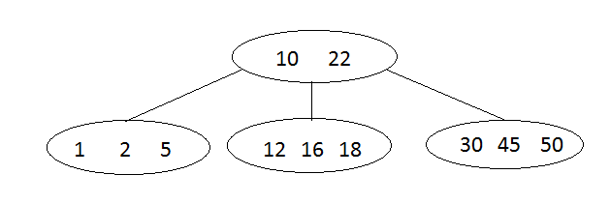

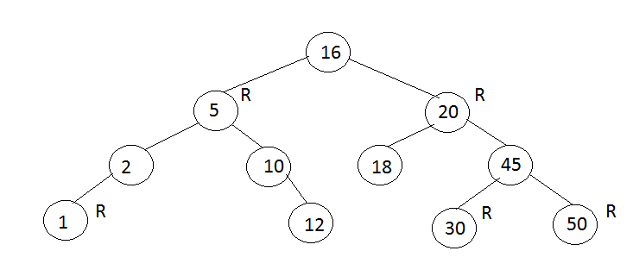

**R-3.14**

1. False, because the root node can’t be red
2. True
3. True, there is only one unique (2,4) associated with a red-black tree
4. False, a single (2,4) tree could have different red-black tree representations

**C-3.10**

**Algorithm** findAllInRange(k1,k2)

S 🡨 new sequence

V 🡨 T.root()

findAllInRange(k1, k2, v, T, S)

return S.elements()

**Algorithm** findAllInRange(k1,k2, v, T, S)

If T.IsExternal(v) then

Return

Else

If key(v) > k1 then

findAllInRange(k1, k2, T.leftChild(v), T, S)

if key(v) ≥ k1 ∧ key(v) ≤ k2 then

S.insertLast(key(v))

If key(v) < k2 then

findAllInRange(k1, k2, T.rightChild(v), T, S)

**Assignment 10**

**R-3.19**

**Algorithm** removeElement(e)

Input e element to remove

Output out element deleted or No_such_element

P 🡨 get the least node in the highest list

y 🡨 after(p)

While e ➢  y.element ∧ y ➢ null do

While e> y do

y 🡨 after (y)

if e ➢  y then

y 🡨 down(left(y))

if e=y then

tmp 🡨 null

while down(y) ➢  null do

tmp 🡨 down(y)

removeNode(y)

return tmp

else

return No_Such_Element

**C-4.16**

**Algorithm** containsDuplicate(S)

Input sequence S contains a list of integers

Output Boolean indicating whether there is a duplicate integer in S

H 🡨 create new hashtable

Foreach v Є S do

existingElement 🡨 H.removeElement(v)

if existingElement ➢  No_Such_Key then

return true

else

H.insertItem(v,v)

Return false

**C-4.18**

**Algorithm** inPlacePartition(S, lo, hi)

Input Sequence S and ranks lo and hi, lo, hi

Output the pivot is now stored at its sorted rank

p 🡨 a random integer between lo and hi

S.swapElements(S.atRank( lo ), S.atRank( p ))

pivot 🡨 S.elemAtRank(lo)

for i🡨 1 to S.size() do

if pivot 🡨 s.elementAtRank(i) then

lo 🡨 lo +1

s.swapElements(S.atRank(lo), S.atRank(i))

j 🡨 lo + 1

k 🡨 hi

while j < k do

while k > j ∧ S.elemAtRank( k ) > pivot do

k 🡨 k – 1

while j < k ∧ S.elemAtRank( j ) < pivot do

j 🡨 j + 1

if j < k then

S.swapElements(S.atRank( j ), S.atRank( k ))

S.swapElements(S.atRank( lo ), S.atRank( k )) {move pivot to sorted rank}

return k

**C-4-19**

**Algorithm** countInversions(S, C, count)

Input sequence S with n elements, comparator C

Output number of inversions in S

if S.size() > 1 then

(S1, S2) 🡨 partition(S, n/2)

countInversions (S1, C, count)

countInversions (S2, C, count)

count 🡨 merge(S1, S2, C, count)

return count

return 0

**Algorithm** merge(A, B, C, count)

Input sequences A and B with n/2 elements each, comparator C

Output number of inversions in S

S 🡨 empty sequence

while ➢A.isEmpty() ∧ ➢B.isEmpty() do

if C.isLessThan( B.first().element(),A.first().element() ) then

S.insertLast(B.remove(B.first()))

Count 🡨 count + 1

else

S.insertLast(A.remove(A.first()))

while ➢A.isEmpty() do

S.insertLast(A.remove(A.first()))

while ➢B.isEmpty() do

S.insertLast(B.remove(B.first()))

return S

**C-4.25**

**Algorithm** matchBolts(A, B)

Input sequence A of n nuts and a sequence B of n bolts

Output sequence contains items of matched nuts and bolts

S 🡨 create new sequence 1

While ➢A.isEmpty() ∧ ➢B.isEmpty() do n

a 🡨 A.removeFirst() n

b 🡨 B.first() n

while ➢a.match(b) do n2

b 🡨 B.next(b) n2

{A match has been found)

b 🡨 B.removeElement(b) n

S.insertItem((a,b)) n

Return S 1

Total running time is O(n2)